**Programming Fundamentals**

**Lab Report**

**Lab 05**



|  |  |
| --- | --- |
| Group Members Name & Reg #: | **Muhammad Haris Irfan**  **(FA18-BCE-090)** |
|  |  |
| Class | Programming Fundamentals CSC103 (**BCE-2B**) |
| Instructor’s Name | Dilshad Sabir |

**In Lab Tasks**

**Question no: 1**

Write a C function **'int test prime(int);'** that takes in a positive number as input and returns ***true*** (1) if the input number is prime or *false* (0) if the input is not prime. Then using this function, write a C program that takes a number (N) as input from the user and prints out the first N prime numbers

**Solution:**

In this Program, I made a function named test prime, in that function I used a for loop with if and else statement, the code is attached below,

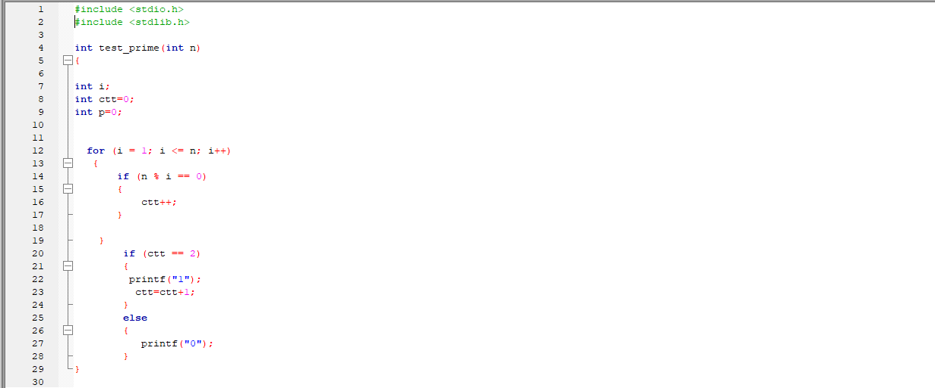

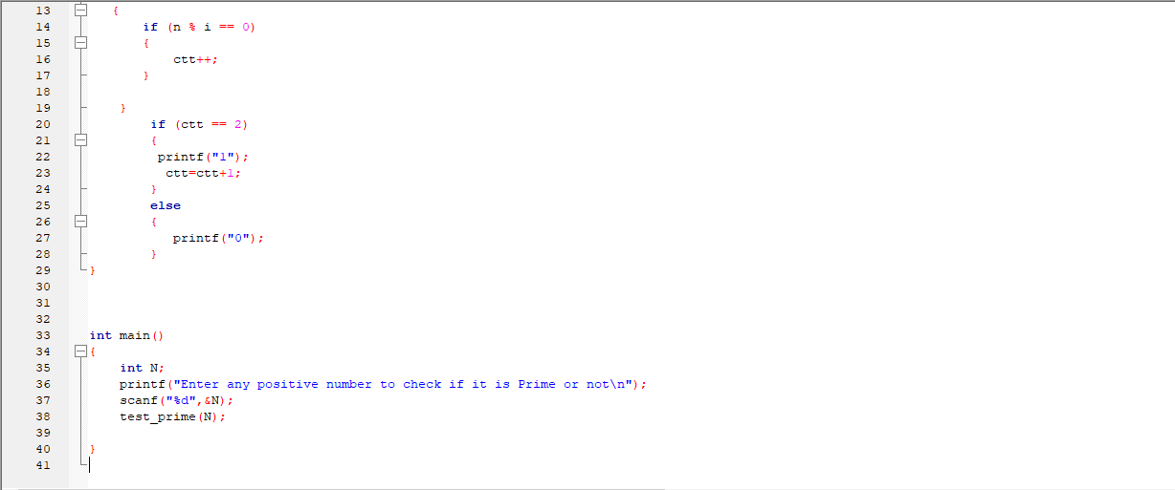

_____________________________

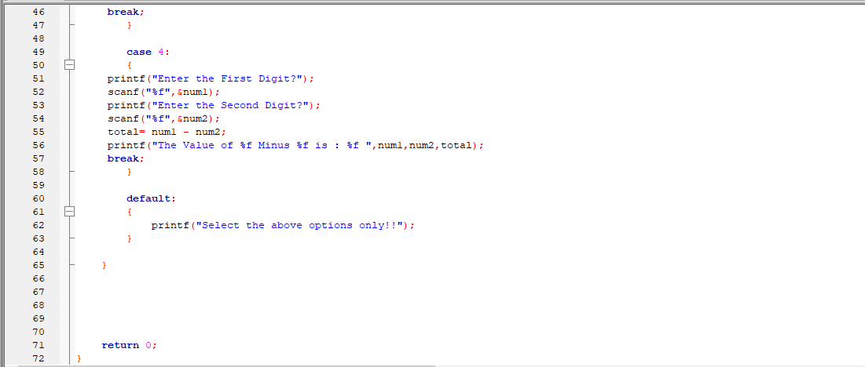

The result for this code is attached below,

When we enter 1, the output is 0, which shows that it is not prime.

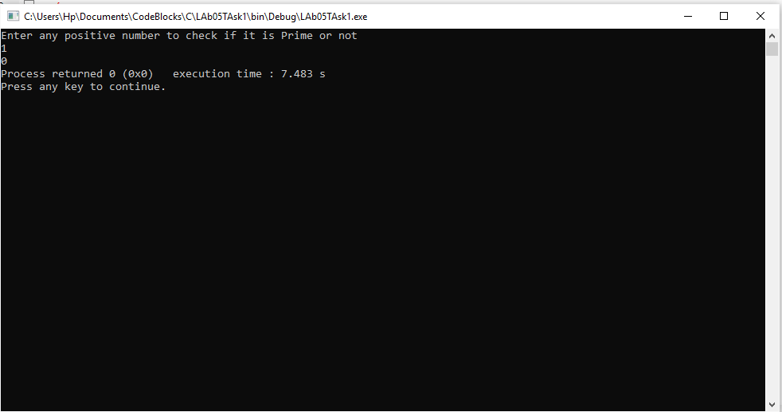

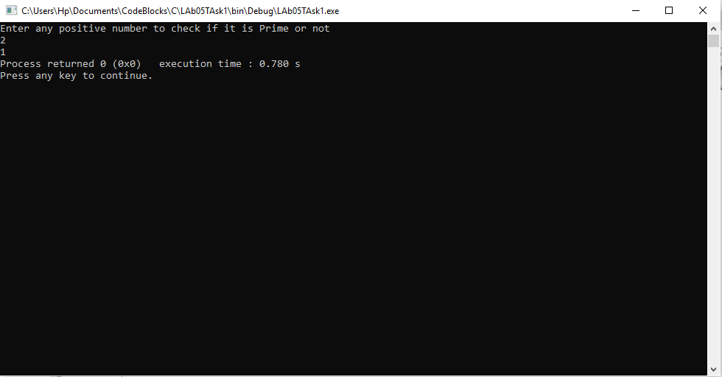When we enter 2, the output is 1, which shows that the number is prime.

Now, for the program that prints n prime numbers, the code is attached below,

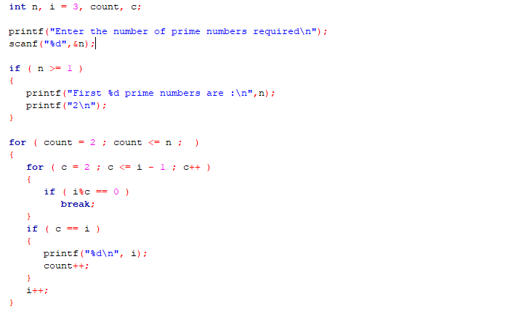

We enter 5 and it prints first 5 prime numbers.

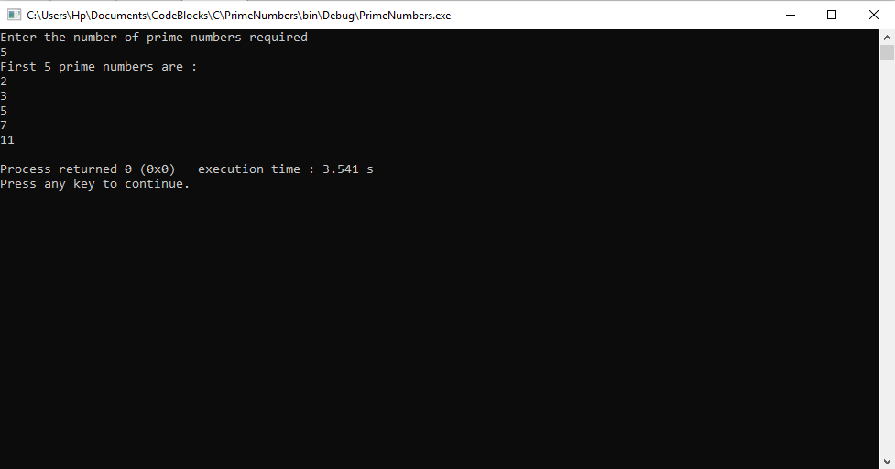

Hence, these results further verify the that our program works for all

values and is correct.

-------------------------------

**Question no: 2(a)**

1. Write a C program that asks user to input a value for  in degrees .It should then calculate the value of the mathematical function  and print its value on screen. Write separate functions to

implement 

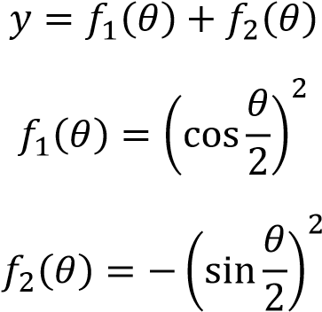

Solution

The code for the following program is attached below, I used made two funtions in this program, f1 and f2

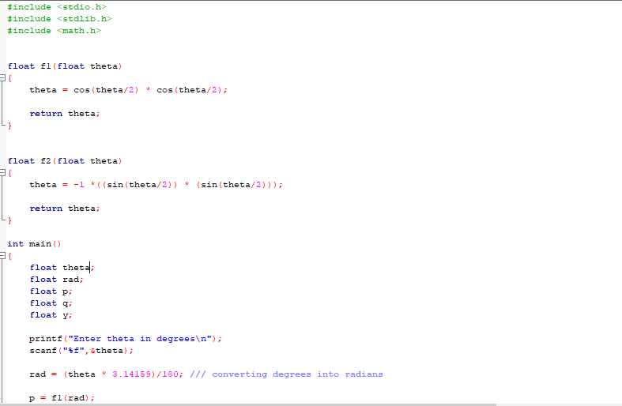

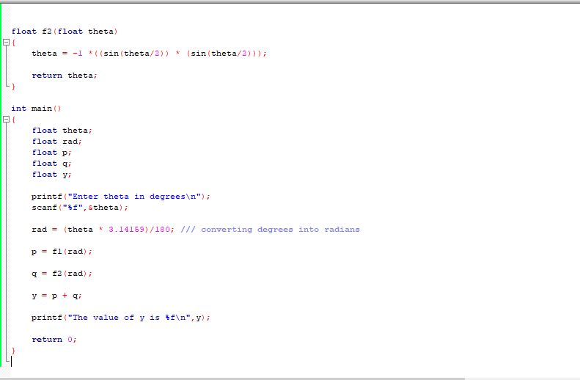

I tested the program for Theta= 90, the result for Y

result is shown below,

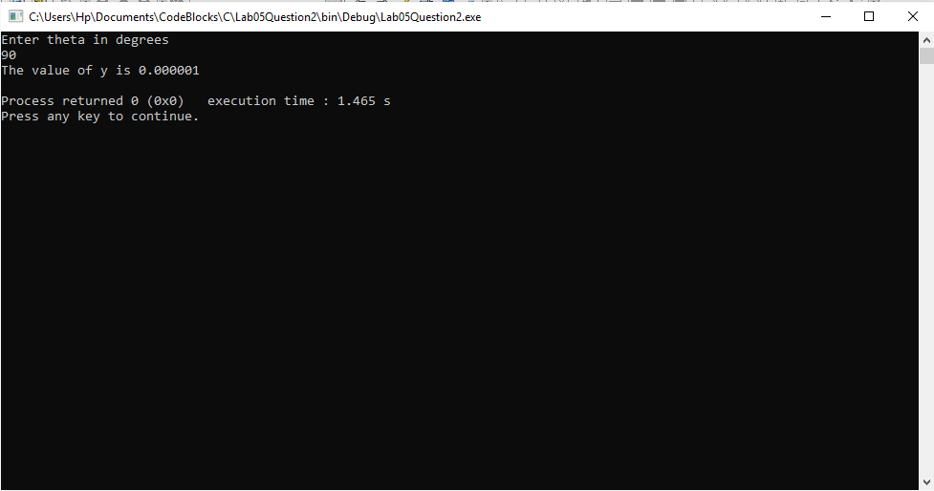

Hence it is correct.

-------------------------------

**Question no: 2(b)**

1. Modify the above program to calculate the value of 

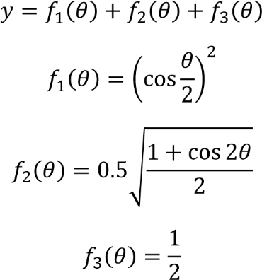

**Solution**

In this Program I used functions just like the previous part, the code and results are attached below.

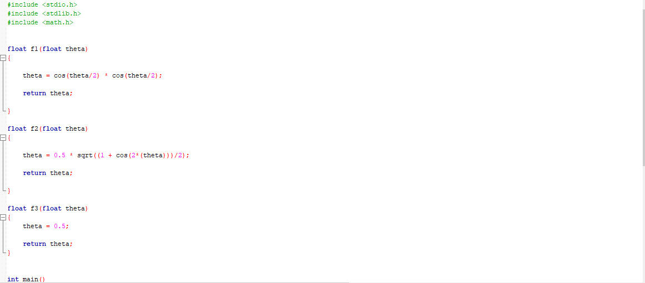

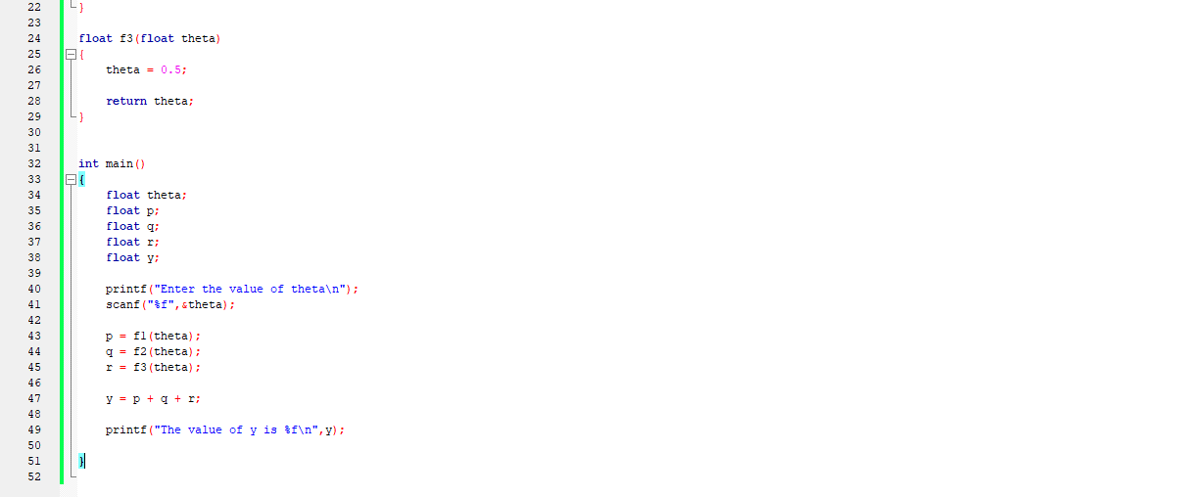

The result for user input 90 is shown below,

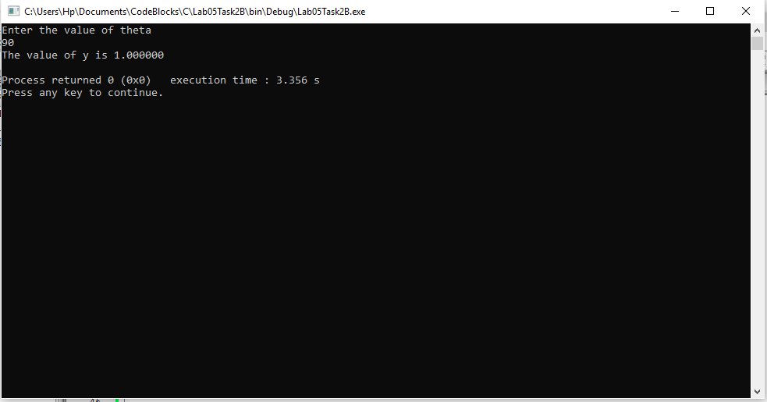

Hence this verifies that our program is correct.

------------------------------

POST LAB

Question:

Write a C program that takes two floating type inputs from the user and calculates their average, individual factorials, and a function . Use separate C functions to compute the average, factorial and the function ‘f’. The program should print the results in the **main** function.

Solution:

In this program I used separate functions for Average, factorial and function ‘F’,

The code and its working is attached below,

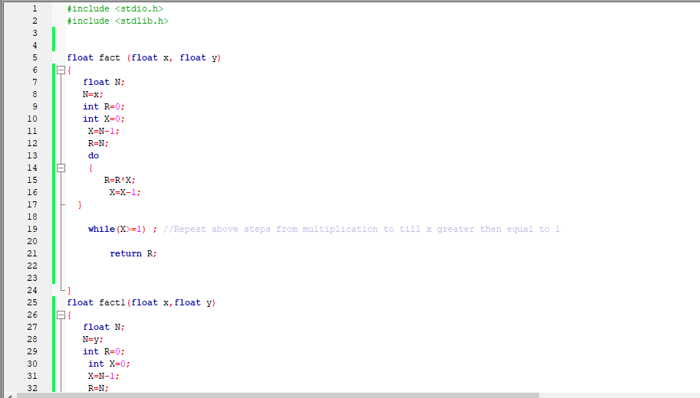

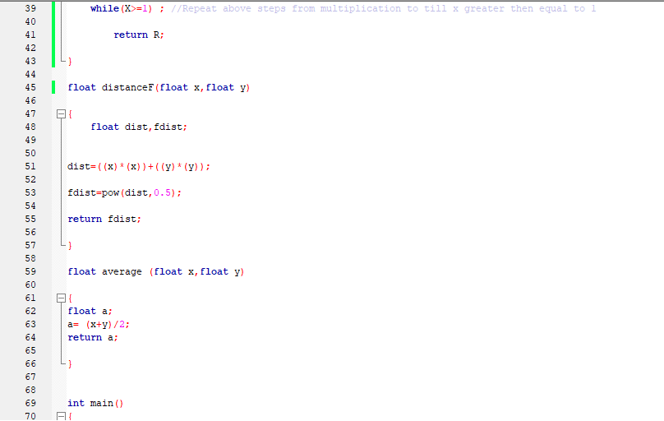

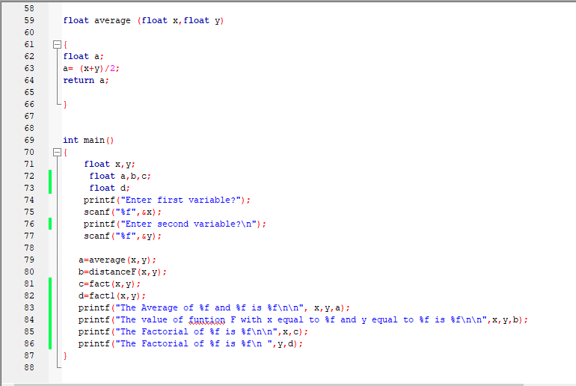

I entered two numbers 6 and 7, their result is shown below,

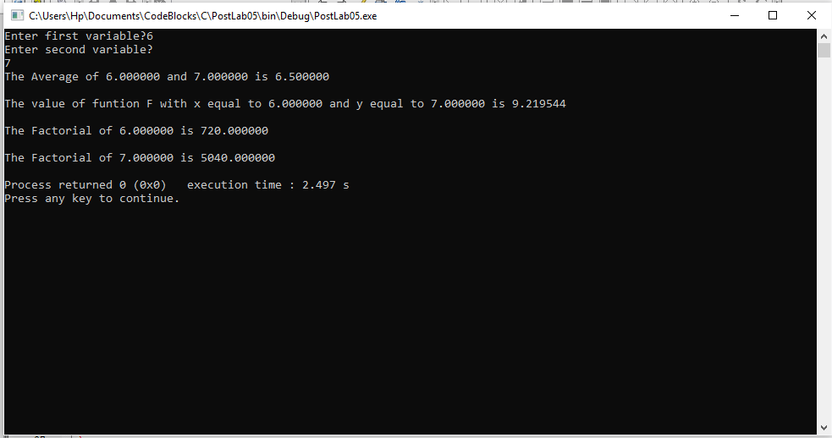

Hence, This further verifies that our program is correct and working.

-------------------------------

THE END